* String is the sequence of characters (it sounds like collectors from Mubashar)
* List is the sequence of anything (it also include the list)

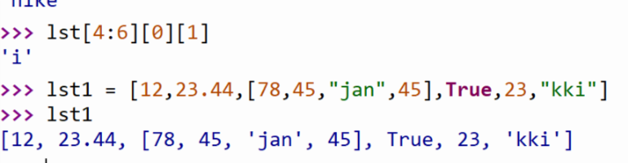

When you need to look at the 0 location, you can use … and it is sth

String objects do not support item assignment.

When you are asked to use the method of the list, you better keep all the elements in the list same type.

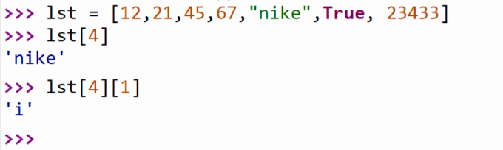

What we should bear in mind is **the slide of the list is part of the list/sublist**

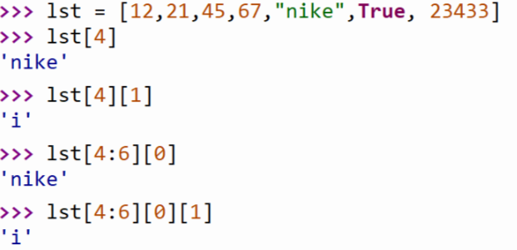

For the string, it is immutable, **so you cannot use the append function to add the string element. And also the remove function to remove the elements in the string.**

The reason why s = s + “1” can work is that the original content in the s was deleted and the new content with adding “1” replace the old one.

**But list can use the append method**

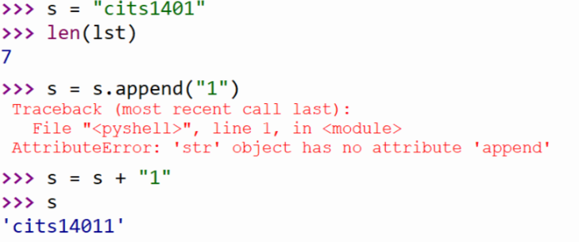

Lists have methods, too

Min ()

Max ()

List () #convert sequence into a list

Append ()

Reverse () # reverse in place a list

Sort () # it is ascending, if we want the descending sequence, use the reverse ()

Copy () # copy the list, there is no connection between those two lists

Join ()

The function of split:

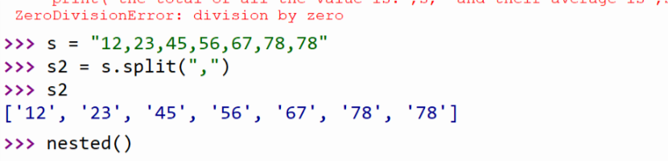

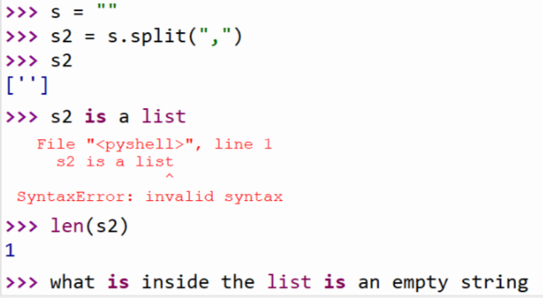

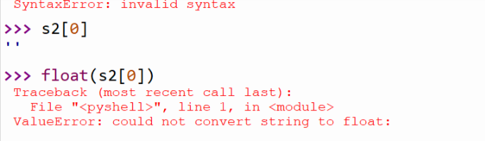

So **the nested () in lecture 12** is not gonna work because when you want to end the program, you just use enter which means an empty string, but actually after the split function, the string become a list and the empty string becomes an element in the string, it would go into the loop again, but you can float the empty string since it would cause error.

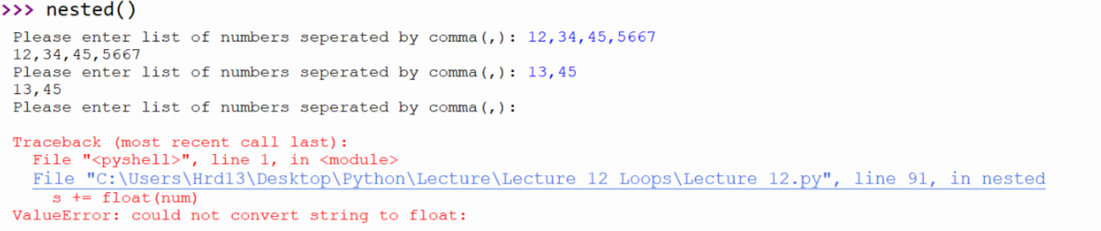

As we all can see, when we change the lst, the lst1 would not be changed

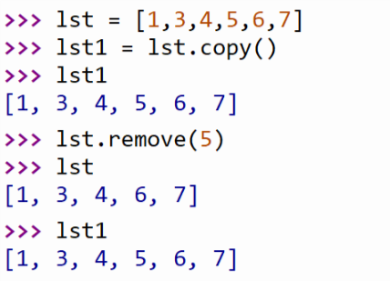

But when you use the equal sign, the lst3 change with the change of lst1 at the same time.

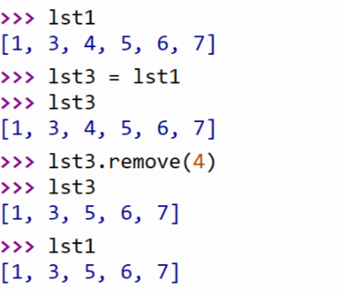

However, when you use “+” to the list, you are creating a new list with different address.

